# CS548 – Assignment Report

## Project Structure – Relationship between Classes

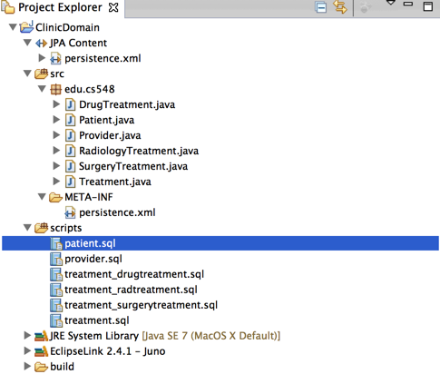

There is a one-to-many relationship between patients and treatments. There is a one-to-many relationship between providers and treatments.The relationships are represented like the following in database:

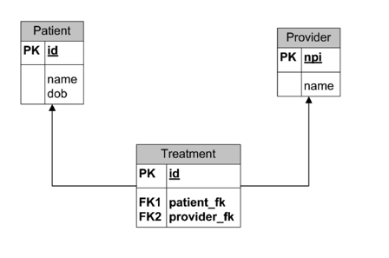

Treatment is an abstract class with concrete sub-classes of DrugTreatment, RadiologiTreatment, and SurgeryTreatment. This relationship of inheritance is represented in Database using **Join Strategy.**

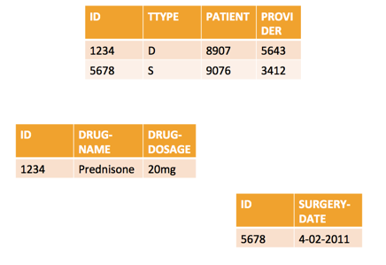

## 2. Console Result

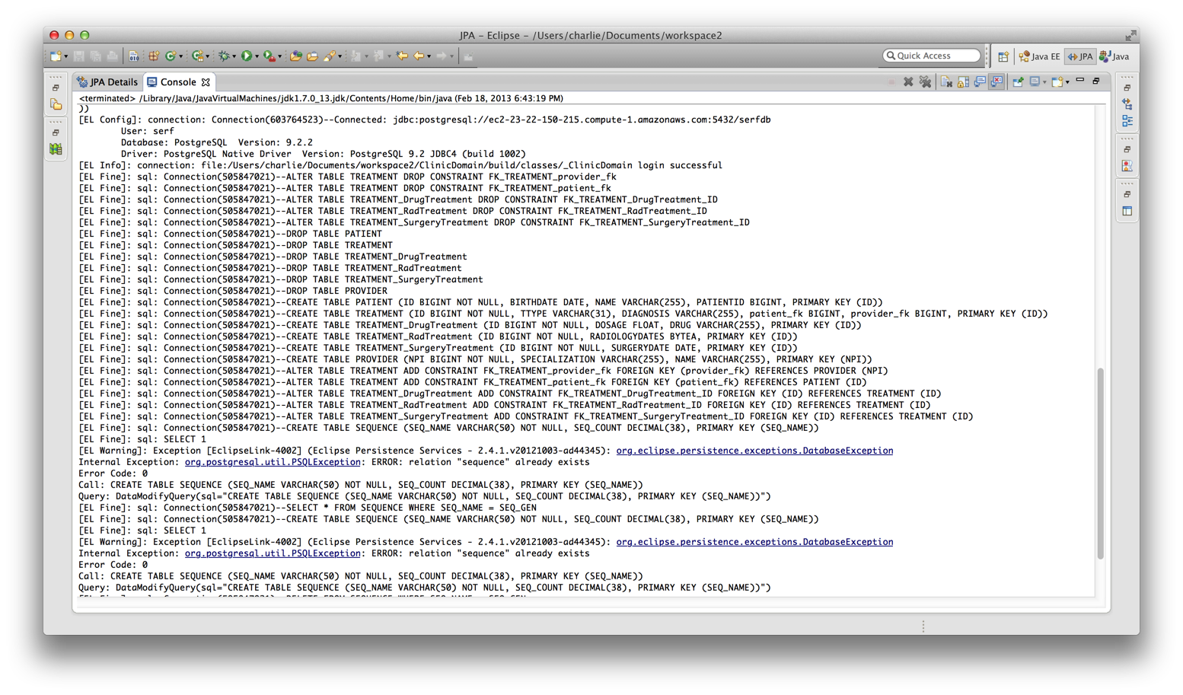

## 3. Database Schema

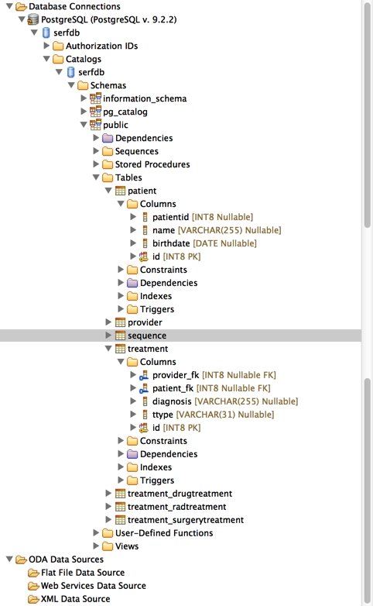

## Appenix – SQL Scripts

--<ScriptOptions statementTerminator=";"/>

**CREATE** **TABLE** patient (

id INT8 **NOT** **NULL**,

birthdate **DATE**,

name **VARCHAR**(255),

patientid INT8

);

**CREATE** **UNIQUE** **INDEX** patient_pkey **ON** patient (id **ASC**);

**ALTER** **TABLE** patient **ADD** **CONSTRAINT** patient_pkey **PRIMARY** **KEY** (id);

--<ScriptOptions statementTerminator=";"/>

**CREATE** **TABLE** provider (

npi INT8 **NOT** **NULL**,

specialization **VARCHAR**(255),

name **VARCHAR**(255)

);

**CREATE** **UNIQUE** **INDEX** provider_pkey **ON** provider (npi **ASC**);

**ALTER** **TABLE** provider **ADD** **CONSTRAINT** provider_pkey **PRIMARY** **KEY** (npi);

--<ScriptOptions statementTerminator=";"/>

**CREATE** **TABLE** treatment (

id INT8 **NOT** **NULL**,

ttype **VARCHAR**(31),

diagnosis **VARCHAR**(255),

patient_fk INT8,

provider_fk INT8

);

--<ScriptOptions statementTerminator=";"/>

**CREATE** **UNIQUE** **INDEX** treatment_pkey **ON** treatment (id **ASC**);

**ALTER** **TABLE** treatment **ADD** **CONSTRAINT** treatment_pkey **PRIMARY** **KEY** (id);

**ALTER** **TABLE** treatment **ADD** **CONSTRAINT** fk_treatment_provider_fk **FOREIGN** **KEY** (provider_fk)

**REFERENCES** provider (npi);

**ALTER** **TABLE** treatment **ADD** **CONSTRAINT** fk_treatment_patient_fk **FOREIGN** **KEY** (patient_fk)

**REFERENCES** patient (id);

--<ScriptOptions statementTerminator=";"/>

**CREATE** **TABLE** treatment_radtreatment (

id INT8 **NOT** **NULL**,

radiologydates BYTEA(2147483647)

);

**CREATE** **UNIQUE** **INDEX** treatment_radtreatment_pkey **ON** treatment_radtreatment (id **ASC**);

**ALTER** **TABLE** treatment_radtreatment **ADD** **CONSTRAINT** treatment_radtreatment_pkey **PRIMARY** **KEY** (id);

**ALTER** **TABLE** treatment_radtreatment **ADD** **CONSTRAINT** fk_treatment_radtreatment_id **FOREIGN** **KEY** (id)

**REFERENCES** treatment (id);

--<ScriptOptions statementTerminator=";"/>

**CREATE** **TABLE** treatment_surgerytreatment (

id INT8 **NOT** **NULL**,

surgerydate **DATE**

);

**CREATE** **UNIQUE** **INDEX** treatment_surgerytreatment_pkey **ON** treatment_surgerytreatment (id **ASC**);

**ALTER** **TABLE** treatment_surgerytreatment **ADD** **CONSTRAINT** treatment_surgerytreatment_pkey **PRIMARY** **KEY** (id);

**ALTER** **TABLE** treatment_surgerytreatment **ADD** **CONSTRAINT** fk_treatment_surgerytreatment_id **FOREIGN** **KEY** (id)

**REFERENCES** treatment (id);

--<ScriptOptions statementTerminator=";"/>

**CREATE** **TABLE** treatment_drugtreatment (

id INT8 **NOT** **NULL**,

dosage FLOAT8,

drug **VARCHAR**(255)

);

**CREATE** **UNIQUE** **INDEX** treatment_drugtreatment_pkey **ON** treatment_drugtreatment (id **ASC**);

**ALTER** **TABLE** treatment_drugtreatment **ADD** **CONSTRAINT** treatment_drugtreatment_pkey **PRIMARY** **KEY** (id);

**ALTER** **TABLE** treatment_drugtreatment **ADD** **CONSTRAINT** fk_treatment_drugtreatment_id **FOREIGN** **KEY** (id)

**REFERENCES** treatment (id);